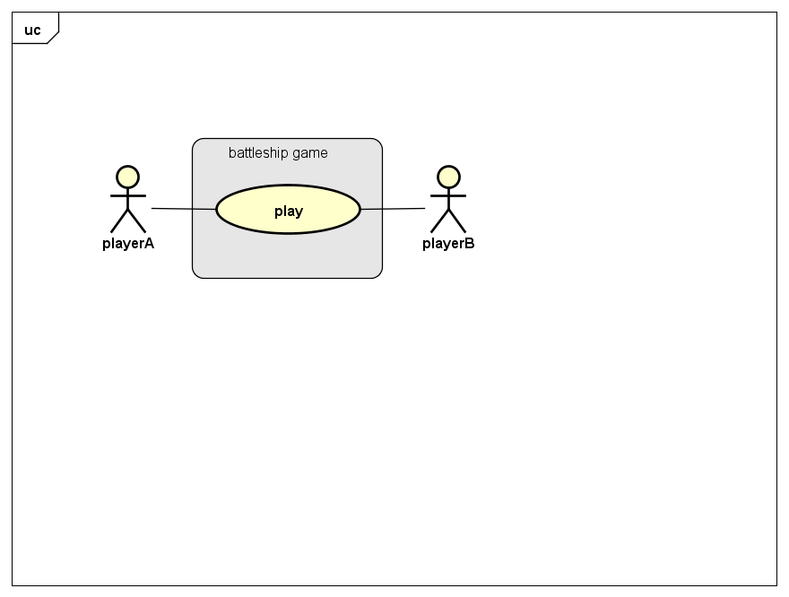

|  |  |  |
| --- | --- | --- |
| Use case name | Play the battleship game | |
| Related requirements |  | |
| Goal in context | Two players A and B come to play the game | |
| Preconditions | A has the acknowledge of binary search before the game starts. | |
| Successful end condition | A wins the game | |
| Failed end condition | B wins the game | |
| Primary actors | A and B | |
| Trigger | Click the start button to begin the game | |
| Main flow | step | action |
|  | 1 | Click the start button |
|  | 2 | A plays the first round |
|  | 3 | B plays the first round |
|  | … | … |
|  | n |  |